DOCUMENTATION

Number Puzzle Game with Scoreboard:

Abstract

The Number Puzzle Game with Scoreboard is a simple game where the user has to guess a randomly generated number. The game keeps track of the user's score, which is the number of attempts it takes to guess the number. The scoreboard is saved to a file, allowing users to view their previous scores.

Introduction

The Number Puzzle Game with Scoreboard is a fun and challenging game that tests the user's guessing skills. The game generates a random number between 1 and 100, and the user has to guess the number by suggesting possible values. After each guess, the game provides feedback in the form of "too high" or "too low" to help the user narrow down the possible range. The game continues until the user guesses the number correctly.

Software Requirements

- Operating System: Windows or Linux
- Programming Language: C
- Compiler: GCC
- Development Environment: Any text editor or IDE

Hardware Requirements

- Processor: Any processor with a C compiler
- RAM: 256 MB or more
- Storage: 10 MB or more

Code:
#include <stdio.h>
#include <stdlib.h>
#include <time.h>

/*
Program Name : Number Puzzle Game
Description : Guess the number and save score to file
Language : C
*/

// function to save score details in file
void saveScore(char name[], int score, int attempts)
{
FILE *fp;

fp = fopen("scorecard.txt", "a");

if (fp == NULL)
{
printf("Error: Unable to open file!\n");
return;
}

fprintf(fp, "Player Name : %s\n", name);
fprintf(fp, "Score : %d\n", score);
fprintf(fp, "Attempts : %d\n", attempts);
fprintf(fp, "--------------------------\n");

fclose(fp);
}

int main()
{
int randomNumber;
int guess;
int attempts;
int maxAttempts = 5;
int score;
char name[50];
char choice;

// initialize random number generator
srand(time(0));

printf("====================================\n");
printf(" NUMBER PUZZLE GAME\n");
printf("====================================\n");

printf("Enter Player Name: ");
scanf("%s", name);

do
{
// generate random number between 1 and 100
randomNumber = rand() % 100 + 1;

attempts = 0;
score = 0;

printf("\nGuess a number between 1 and 100\n");
printf("Maximum Attempts Allowed: %d\n", maxAttempts);

// guessing loop
while (attempts < maxAttempts)
{
printf("\nEnter your guess: ");
scanf("%d", &guess);

attempts++;

if (guess == randomNumber)
{
printf("Congratulations! Correct Guess 🎉\n");
score = (maxAttempts - attempts + 1) * 10;
break;
}
else if (guess > randomNumber)
{
printf("Your guess is TOO HIGH!\n");
}
else
{
printf("Your guess is TOO LOW!\n");
}
}

// if user fails to guess
if (guess != randomNumber)
{
printf("\nGame Over ❌\n");
printf("Correct Number was: %d\n", randomNumber);
score = 0;
}

printf("\nTotal Attempts Used: %d\n", attempts);
printf("Your Final Score : %d\n", score);

// save score to file
saveScore(name, score, attempts);

printf("\nDo you want to play again? (y/n): ");
scanf(" %c", &choice);

} while (choice == 'y' || choice == 'Y');

printf("\nThank you for playing the game!\n");
printf("Your score is saved in 'scorecard.txt'\n");

return 0;
}
RESULT:

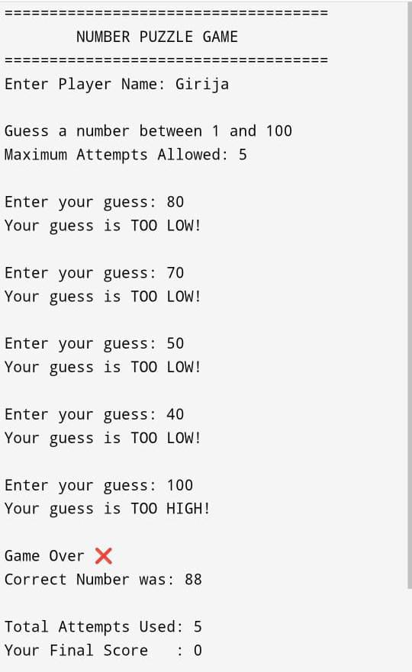

Conclusion
The Number Puzzle Game with Scoreboard is a fun and challenging game that tests the user's guessing skills. The game is simple to play, and the scoreboard feature adds an extra level of excitement by allowing users to track their progress. The game can be further improved by adding more features, such as different difficulty levels or a timer.

